Spatial and temporal variability in economic availability of residual biomass from timber harvest in west-central Alberta, Canada (1990–2015)

Glen W. Armstrong1,✉, Jay A. Anderson2, and Alex W. McPhee2

2021-11-18

1 Department of Renewable Resources, University of Alberta, Edmonton AB T6G 2H1, Canada  
2 Department of Resource Economics and Environmental Sociology, University of Alberta, Edmonton AB T6G 2H1, Canada

✉ Correspondence: [Glen W. Armstrong <[gwa@ualberta.ca](mailto:gwa@ualberta.ca)>](mailto:gwa@ualberta.ca)

# 1 Introduction

1. **Focus on cost variability associated with transportation and forest characteristics**
2. **Based on historical harvest locations (1990-2015)**

Need to reference Yemshanov [1] and Blackburn [2]. Our strengths

1. Availability of data
2. Temporal variability
3. suitability for mid-level analysis
4. ultra-cool graphics

## 1.1 Justification

* renewable fuels better than fossil fuels
* forest harvest residue just piled and burned
* forest road networks in Alberta radiate from location
* terrain is difficult
* simple circle or doughnut models of limited utility `

# 2 Materials and methods

We describe here our study area, data sources, and method.

## 2.1 Study area

We use the province of Alberta in western Canada as our study area. It occupies 661 848 km2. Its southern boundary is 49°N latitude, northern boundary is 60°N latitude, eastern boundary is 110°W longitude, and its western boundary is defined by 120°W longitude and the Great Divide of the Rocky Mountains (Figure 1).

The southeastern part of the province is largely privately owned agricultural land, but the northern and western parts are largely publicly owned forested land. There is a substantial area of privately owned agricultural land in the Peace River Country of northwestern Alberta. There are also substantial areas in National Parks along the Rocky Mountains and in the far north of the province. The province calls the area of mostly publicly owned forested land (excluding those National Parks) as the Green Area, and the area of mostly privately owned agricultural land as the White Area. About 90% of the harvested timber volume in Alberta comes from the Green Area.

For administrative purposes, the Green Area is divided into Forest Management Units (FMUs). The province also enters into long term agreements with forest products companies giving the companies the rights to timber harvest and the responsibility to manage the forest sustainably. These agreements are called Forest Management Agreements, and the areas under agreement are called Forest Management Agreement Areas (FMAAs). For the most part, the boundaries of the FMAAs are now coincident with FMU boundaries, with the exception of the Alberta-Pacific FMAA in eastern Alberta comprises 12 FMUs. Maps of the FMUs [3] and the FMAAs [4] can be found on the Government of Alberta website. The FMU and FMAA boundaries are important to this study as they are used to look up average piece size and utilization standards. We discuss piece sizes and utilization standards later.

Our focus for this study is the forest near Hinton, Edson, and Whitecourt in west-central Alberta. These towns were chosen as they host several forest products companies and are located near several active FMAAs. We assume that a residual forest biomass processing plant would be located near an existing forest products mill as the forest road network has been developed to supply those mills. Locating a forest residue processing plant near a forest products mill would also allow for convenient access to mill residues.

The FMAAs which supply most of the timber to mills near our three locations are West Fraser Mills Ltd. (Hinton), West Fraser Mills Ltd. (Edson), Weyerhaeuser Company Limited (Pembina Timberlands), Millar Western, Blue Ridge Lumber Inc., and ANC Timber Ltd.

We used the Weyerhaeuser oriented strand board plant in Edson, the Millar Western Forest Products Ltd. pulp mill in Whitecourt, and the West Fraser pulp mill in Hinton as the locations for the hypothetical forest residue processing facilities.

As well as considering locations for the hypothetical plants, we considered 3 different plant capacities defined by annual biomass requirements: 200 Gg/a corresponding to a small wood pellet mill, 400 Gg/a corresponding to a large pellet mill or a small ethanol plant, and 800 Gg/a corresponding to a large ethanol plant.

## 2.2 Data sources

We used a number of publicly available datasets to create the township-level summary data used in our analysis. Most of the data are freely available on the World Wide Web (WWW). Much of the data processing required for this study was manipulation of spatial data. This was done using the QGIS geographic information system software [5] and add-ons. All national level data were clipped to the Alberta provincial boundary for further analysis.

The datasets are introduced here. Their use will be discussed in detail later.

### 2.2.1 Altalis

Altalis manages much of the spatial data created by or for the Government of Alberta. We use several coverages from their base features database product [6]: the provincial, Green/White area, forest management unit (FMU), forest management agreement area (FMAA), Alberta Township Survey System township, and town boundaries.

The Alberta Township Survey System (ATS) is particularly important to this study as all the data used for this study are aggregated or disaggregated to the township level. ATS provides the basis for legal land descriptions in Alberta. The typical township is roughly square (9.778 km by 9.716 km, 9 500 ha) and is indexed by township (1–126), range (1–30), and meridian (4–6). The townships immediately east of Alberta’s western boundary, and immediately east of the 5th and 6th meridians (corresponding to 114°W and 118°W longitude, respectively) are partial townships and therefore deviate from the roughly square shape. ATS is described in detail by the Alberta Land Surveyor’s Association [7]. There are 7 237 townships in Alberta, allowing for spatial resolution appropriate for regional or provincial level analyses.

### 2.2.2 Alberta Geospatial Services

Alberta Geospatial Services is operated by the Alberta Ministry of Environment and Parks [8]. We obtained road access coverages from here. A road access coverage is also available from Altalis but it does not have as detailed information on road class.

### 2.2.3 National Forest Information System

The National Forest Information System (NFIS) provides a set of spatial data layers representing forest properties at a 250 m resolution for all of Canada [9]. We used the merchantable volume, stand age, and species composition attributes from these data layers.

Another product of NFIS is a set of spatial datasets derived from satellite data [10]. The dataset used for this study is the harvest year data set for the years 1985-2015. The dataset is described in detail by Hermosilla *et al.* [11]. It consists of a raster for Canada at 30 m resolution indicating the year of harvest for each cell.

The NFIS also provides a web-based individual tree biomass calculator [12]. It is used to calculate stem wood, stem bark, branch, and foliage biomass for a tree based on province, ecozone, species, diameter at breast height (DBH) and height. It is possible to upload a file representing many trees with different combinations of these input parameters and download a file containing the calculated results for all the trees.

### 2.2.4 Natural Resources Canada

Ung *et al.* [13] describe the tree taper models developed for Canada. A valuable contribution related to this is the WWW-based wood volume calculator that uses those models [14]. We use the taper models developed by Ung *et al.* to calculate merchantable volumes and the amount of residual biomass available from cutblocks in each of the townships in each year.

### 2.2.5 National Forestry Database

The national forestry database [15] was used to summarize the timber harvest volume and harvest area from Alberta for the years 1990-2015. This information is used to adjust the volumes obtained from the 250 m resolution inventory to better reflect average harvest volumes observed in Alberta.

### 2.2.6 Forest management plans

The Alberta government requires FMA holders to develop a forest management plan for the FMAA. The forest management plans were used to get information on utilization standards and average piece size of harvested trees for the FMAA [16].

### 2.2.7 Agriculture and Agri-Food Canada

The boundaries of Canada’s terrestrial ecozones can be found on Agriculture and Agri-Food Canada’s website [17]. Ecozone is an input to the individualt tree biomass calculator [12].

# 3 Data aggregation and modeling

The GIS analysis for this paper was done using QGIS [5]. Data summaries and statistical analysis were done using R [18] with RStudio [19], and tidyverse [20].

The primary objective of this paper was to quantify the spatial and temporal variability of the costs associated with recovering the residual biomass left on forest cutblocks following timber harvest. A driving assumption for this model was that residue recovery is opportunistic. Loggers make the decision about what and where to harvest, and the biomass recovery occurs at some time following timber harvest. The decision to harvest is made independently of any knowledge of the value of residue as biomass. The biomass gleaners provide a service to the loggers as the residue would be piled and burned if it was not recovered as biomass.

Every township will have associated with it a cycle time (and cost) required to transport harvest residue from the township to each of our 3 plant locations, a measure of residual biomass for each of the 26 years in the study period. For each plant location and year, the model looks at all the townships in the province that have a positive residual volume, and begins the creation of cumulative residual biomass curves starting with the lowest cycle time first. These lists of cycle time and cumulative biomass provide the data for the marginal cycle time and cost curves.

This is a greedy algorithm. It ignores the cost of moving equipment from one block to another, but we believe it still provides useful information.

## 3.1 Cycle time estimates

The provincial road network was sorted into four classes: primary highways, other paved roads, two-lane gravel roads, and one-lane gravel or dirt roads. Loaded and unloaded travel speeds were assumed for each road class, according to Table 1. These travel speeds are based on those assumed by FPInnovations for the Dawson Creek Timber Supply Area in the neighbouring province of British Columbia [21].

The harmonic mean of loaded and unloaded speeds was calculated as

$$\overset{‾}{s_{h}}={\left(\frac{s_{l}^{−1}+s_{u}^{−1}}{2}\right)}^{−1}$$

where $s_{l}$ is the loaded speed and $s_{u}$ is the unloaded speed. Use of harmonic mean allows us to calculate the correct cycle time: the time required to travel from the mill, to the collection site at the cutblock, and back to the mill. This provides the basis for our estimates of haul cost.

Figure 3 illustrates the road network in Alberta and estimates of cycle time based on the average of loaded and unloaded speeds from Table 1. The road network in the White Area of the province is very dense and largely arranged as a grid related to the Alberta Township Survey System. Most of the roads in the White Area are public. The road network in the Green Area is less dense and many of the roads are built and maintained by resource industries (*e.g.* forestry and petroleum & natural gas). The pattern of the road network is not as regular as in the White Area.

One-way haul times based on the harmonic mean travel speed were generated using the QGIS Network Analysis Toolbox 3 plug-in (QNEAT3) created by Raffler [22], specifically its iso-area as interpolation (from point) algorithm. In our case, we used the algorithm to determine the minimum one-way travel time (using the harmonic mean of loaded and unloaded speeds) along the road network from each of our centres to each cell of a provincial level raster at a 200 m resolution. Off-road travel was assumed to be at 5 km/h. The underlying algorithm for travel time minimization is that of Dijkstra [23]. Cycle times were calculated by multiplying the one-way haul time by 2, and adding 1 hour for loading and unloading

QGIS zonal statistics were used to calculate the median cycle time to each township, from each of our three centres. The cycle time in Figure 2 was limited to 14 hours because, in Alberta, drivers of commercial vehicles are not permitted to drive more than 13 hours in a 24-hour period, and spend no more that 14 hours on-duty, including loading and unloading times.

## 3.2 Biomass collection costs

All costs and prices used in this study are in Canadian dollars ($). At the time of writing (2021-11-18 19:32:42 GMT), the exchange rate between Canadian (CAD) and US dollars (USD) was 0.7932 USD/CAD.

All measures of biomass used in this study are reported in SI units on a dry matter basis: 1 Mg is equivalent to 1 oven dry metric ton.

We assume that the biomass available for collection at a cutblock includes the tops, branches, and foliage left at a roadside landing after processing by a stroke delimber. The delimber is assumed to top the log at the top diameter specified in the utilization standard relevant to the harvest area. Our focus in this study is on the spatial and temporal variation in biomass collection costs based on residue availability associated with cycle times. Following Röser [24], the cost of recovering residues from a roadside stroke-delimber , excluding transport, is 41.60 $·Mg-1.

We assume that the residue will be transported from the forest using a live floor chip van with 100 m3 capacity. The USDA Forest Service’s Forest Residue Transportation Costing Model [25] assumes a default solid volume factor of 0.3 for biomass meaning that a 100 m3 capacity trailer could hold the equivalent of 30 m3 of solid biomass.

This equates to 11.40 Mg of biomass assuming a specific gravity of 0.38 which is the specific gravity of lodgepole pine wood and bark on a green volume basis according to Miles and Smith [26].

Timber Tracks produces a publication describing forestry equipment hourly rates [27]. The rate reported for tandem tractor with a tandem trailer was 157.31 $/h. We assume that the tractor-trailer combination used to haul biomass would cost a similar amount.

Therefore, the cost of transporting residual biomass was set to 13.80 $·Mg-1·h-1.

## 3.3 Harvested area

The areas harvested by township in 2009 according to NFIS [10] [11] are shown in relationship to the three plant locations and the Green Area in Figure 1. Similar aggregated data were created for each of the years 1990–2015. For each township, and each of the years between 1990 and 2015, we store the area harvested (ha) for use in our analysis. We can see from this map that a great deal of timber harvest took place near our hypothetical plant locations in 2009.

These data were created by using QGIS zonal statistics to sum the area harvested in each township in each year based on the 30 m resolution harvest data [10].

## 3.4 Utilization standards

Many forest products companies operate in Alberta, and the details of their agreements with the government with respect to forest management differ. Some companies have harvesting rights to just the needleleaf species, others have rights to just the broadleaf species, and some have rights to both needleleaf and broadleaf.

Utilization standards in Alberta are specified on the basis of stump height, minimum stump diameter (outside bark), and minimum log length to a specified top diameter (inside bark). Utilization standards vary by FMU. Stump heights used in Alberta are 15 and 30 cm; stump diameters are 13 or 15 cm; top diameters range between 7 and 12 cm; and minimum log lengths range between 2.44 and 4.88 m. These utilization standards are necessary to relate volumes calculated to the 13+/7 cm standard for the National Forest Inventory to the harvest volumes reported by the companies. Perhaps most importantly, the minimum top diameter will have an effect on the volume of residue left in the forest corresponding to the tops of trees.

Based on the FMU boundaries, we assign a needleleaf and broadleaf utilization standard to each township.

## 3.5 Characteristics of the “average” tree

### 3.5.1 Piece size

FMA holders are required by Alberta to project average piece size in the detailed forest management plans (DMFPs) for their FMAAs. We use these piece sizes projected for the first period of the DMFP. They range from 0.110 to 0.599 m3 per tree. We used the piece size reported for the first 5-year period of the 200-year planning horizon. For those areas where piece size was not reported we assumed an average piece size of 0.278 m3 for needleleaf trees and 0.264 m3 for broadleaf trees. These are the average of the values reported in the forest management plans. These values are based on the utilization standards used on the FMA. Based on the FMU boundaries we assign an average piece size for broadleaf and needleleaf trees to each township.

### 3.5.2 Taper functions

Ung *et al.* [13] present taper models and the associated coefficients for the tree species found in Canada. These taper models can be used to find the diameter at any point along the main bole of a tree given species and diameter at breast height (DBH). DBH is a commonly used tree measurement and is the diameter of the tree measured at 1.3 m above ground level, in most jurisdictions, including Alberta. It is straightforward to determine cross-sectional area of the tree at any height. Integrating this area function will yield volume between any two heights.

They present a one-parameter model which is useful when both tree DBH and height measurements are available.

$$d\left(d_{b},h\right)={\left(d_{b}^{2}\frac{H−h}{H−1.3}{\left(\frac{h}{1.3}\right)}^{2−β_{2}}\right)}^{−2}$$

where $d$ is the diameter (cm) at height $h$ (m), and $d_{b}$ is the diameter at breast height (1.3 m above ground level), and $H$ is tree height (m).

For those cases where height measurements are unavailable, they present a 3-parameter model, where H is replaced with $β_{0}d_{b}^{β_{1}}$.

$$d\left(d_{b},h\right)={\left(d_{b}^{2}\frac{β_{0}d_{b}^{β_{1}}}{β_{0}d_{b}^{β_{1}}−1.3}{\left(\frac{h}{1.3}\right)}^{2−β_{2}}\right)}^{−2}$$

where $d$ is the diameter (cm) at height $h$ (m), and $d_{b}$ is the diameter at breast height (1.3 m above ground level)

Implicit in this equation is an equation for tree height

$$H\left(d_{b}\right)=β_{0}d_{b}^{β_{1}}$$

which we will use to create input for the biomass calculator

The radius of the tree (m) can be calculated from $d_{b}$ and $h$ using

$$r\left(d_{b},h\right)=\frac{d\left(d_{b},h\right)}{200}$$

where the constant 200 is used to convert a diameter (cm) to a radius (m).

$$a\left(d_{b},h\right)=πr{\left(d_{b},h\right)}^{2}$$

The volume of the merchantable log between stump height $h_{s}$ and the height of the tree at the minimum top diameter ($h_{t}$) can then be calculated through integration.

$$v\left(d_{b},h_{s},h_{t}\right)=\int_{h_{s}}^{h_{t}}{π}r{\left(d_{b},h\right)}^{2}dh$$

Ung *et al.* also present a simple linear model relating outside bark to inside bark diameter. The taper function is for outside bark diameter, but piece sizes are reported as inside bark volume.

### 3.5.3 DBH and height estimates

From information collected from forest management plans we have an estimate of average piece size calculated to a specified utilization standard for every combination of township and FMU, for both needleaf and broadleaf trees. We used a binary search procedure to find DBH and height of the “average” broadleaf and needleleaf tree in each township based on the FMP utilization standard. An average piece size to the 13+/7 utilization standard was also calculated by integrating the cross-sectional area function using the appropriate limits.

Most forest stands in Alberta are considered to be even-aged, as the majority originated following stand-replacing fire or clearcut harvest. It is common to describe stands using a distribution of diameters at breast height (DBH). The diameter distribution for an even-aged stand is usually approximately normal [28]. We use this to justify the use of the average tree.

Using these equations, we are able to calculate wood volumes and bark volumes between any two heights along the tree stem. We calculate the proportions of total tree and bark volumes in the top of the tree. We use this volume proportion later to calculate biomass of stemwood and bark in the top.

The merchantable volume for the average tree is calculated to both the 13+/7 cm utilization standard and the utilization standard specified for the FMU. The 13+/7 utilization standard is used to calculate the stand density (stems/ha) for both the needleleaf and the broadleaf species. The FMU utilization standard is use to calculate the volume adjustment factor.

### 3.5.4 Individual tree resdual biomass.

Canada’s national forest inventory website provides a useful individual tree biomass calculator [29]. It calculates the biomass of tree components (stem wood, stem bark, branches, foliage, and total) using province/territory, terrestrial ecozone, species, DBH, and tree height as input. It is possible to upload a file to the calculator so that the biomass of many trees can be calculated at once. The calculator is based on work by Lambert *et al.* [30].

We created an input file for the NFIS biomass calculator that included all 125 unique combinations of species, ecozone, DBH, and height assigned to the townships in the previous sub-sub-section (**Create cross-references**).

We assume that the residual biomass is in the stem wood and stem bark from the tops of the harvested trees and the branches and foliage. The residual biomass from the tops is calculated using the total biomass of stem wood and stem bark adjusted by the volume proportions calculated above.

## 3.6 Spatial variability in residual biomass production

There is considerable spatial variability in the amount of timber harvest residues available for biomass collection. The variability relates to the distribution of harvested species and age classes across the landscape, to the timber harvesting practices of different operators, and to other factors. We used the 250 m resolution raster maps of Canada’s forest attributes for 2011 from Natural Resources Canada [9] to retrieve information on species composition, age classes, and merchantable volume. The data were clipped to the Alberta boundary. Merchantable volumes for Alberta in this dataset were compiled to the 13+/7 cm utilization standard, meaning that stump height for each merchantable tree was assumed to be 30 cm, that stump diameter (outside bark) was at least 13 cm, and that the length of the log to a 7 cm inside bark diameter was at least 4.88 m. This is one of the utilization standards used in Alberta and was the one used for Alberta data in Canada’s National Forest Inventory (NFI henceforth) [31].

Forestry companies are selective in the stands they harvest. Some stands will be comprised of undesirable species. The most commercially important needleleaf species in Alberta are white spruce (*Picea glauca* (Moench) Voss), lodgepole pine (*Pinus contorta* var. *latifolia* Engelm.) and jack pine (*Pinus banksiana* Lamb.). Trembling aspen (*Populus tremuloides* Michx.) is the most commercially important broadleaf species. Some stands may have too little volume to be worth harvesting. Some stands may be too young. We selected cells that contained at least 50 m3·ha-1 of merchantable volume, as that corresponds with merchantability limits specified in Alberta [32]. We filtered out cells with more than 50% crown closure of larch (*Larix spp.* Mill.) and birch (*Betula spp.* L.) combined as those genera are rarely harvested at a commercial scale in Alberta. We filtered out cells with stand age less than 80 years as it is unusual to harvest stands younger than that in Alberta. QGIS zonal statistics were used to average the merchantable volume per ha of the merchantable cells in each township.

Then for each township, we determined the most common needleleaf and broadleaf species, and calculated the average volume per hectare of needleleaf and broadleaf these harvestable stands.

These average volumes are still considerably less than the average volume per hectare harvested in Alberta, indicating that the forestry companies are even more selective about timber harvest than our simple filter rules suggest.

Based on data retrieved from the National Forestry Database, the average harvest volume in Alberta between 1990 and 2015 was 277.8 m3·ha-1 [33]. The average township volume after the filter was applied was 100.3 m3·ha-1. We used a harvest volume adjustment factor of 2.77 to make the volumes we calculated comparable to the average harvest volume (m3·ha-1) for Alberta.

## 3.7 Residue yield (Mg·ha-1) by township.

For each township, we calculate the number of stems by dividing the adjusted volume per hectare by the average piece size for both needleleaf and broadleaf trees. We assume that for the types of stands being harvested that the stem count per hectre for the 13/+7 utilization standard is close to the stem count based on the FMU utilization standard. We multiply the stem count by the average tree residual biomass. We assume an average recovery factor of 0.624 following what Peltola *et al.* [34] determined for Finland, recognizing that some of the residual biomass will be unrecoverable. Together this gives us an estimate of the average residue yield when a hectare of a stand in a particular township is harvested.

## 3.8 The model

The bulk of the effort expended on this study was spent in creating township-level summaries for use by the model. The model itself is very simple. We assume that the residue collectors follow a kind of greedy optimization. They take the cheapest residue first, and stop when they reach plant capacity. For each combination of plant location and year, all the townships in Alberta were sorted by ascending cycle time (equivalently tranport cost). The model works through this list, cumulating harvest residue recovered from the harvest area associated for the township and year, and provided a file showing cycle time, total cost, and cumulative residue recoverd. Once this file is created, fairly simple data manipulations are undertaken to produce the results.

As with all models, this is a simplification. One avenue that we would like to explore in future work is incorporation of the costs of moving equipment from one cutblock to the next.

## [1] NA

## Saving 5 x 4 in image

## Warning: Removed 6 row(s) containing missing values (geom_path).

# 4 Results and discussion

## 4.1 The volume adjustment factor

As a check, we obtained harvest volumes from Alberta for the period 1990-2015 from the national forestry database [15]. Note that in 1998, industrial salvage volumes of 369 791 m3 of softwood and 264 647 m3 are not included in the harvest levels shown in the graph.

## 4.2 Township level biomass

## 4.3 Distributional results

Figures 9 and 10 display marginal cycle time (h) and marginal costs ($·Mg-1) for each of the 26 years in the study period, and for the 3 alternative plant locations. Curves for 1990, 2009, and 2005 are highlighted represented the years of minimum, median, and maximum provincial harvest volume in the period. The inter-year variation in marginal costs increases as the cumulative amount of residue collected increases. We can also see that the relative position of the years in terms of cost varies between the plant locations: *e.g.* the year 2005 is not as good for Hinton, as it was for Edson and Whitecourt.

Figure 11 is another way of presenting the year to year variation in the distribution of costs between the plant locations and assumed capacity: the boxplots display the quartiles and the minimum and maximum costs require to supply a plant of a given capacity at each of the locations in each of the years. Here again, we can see the variability increasing as plant capacity increases.

Figure 12 shows the average cost ($·Mg-1) for each location, capacity, and year. Overall, the average costs in Edson and Whitecourt are quite similar. Hinton is usually more expensive across years and capacities. The differences become clearer at a capacity of 800 Gg, where Whitecourt is the low cost location for most of the years.

Table 2 presents summary statistics over the 26 year for the locations and capacities. It is clear that average costs and the inter-annual variability of costs increase with increasing capacity. It is clear that the variation is costs for Hinton is greater than for Whitecourt and Edson, particularly for the 800 Gg/a capacities.

Figure 13 shows the areas that would have been needed to supply a plants of varying capacities in Whitecourt in the year of median harvest (2009) in relation to the proportional township area harvested. There is some residue being collected from the White area, but most of it is being collected from the green area.

Figure 14 compares the supply areas for 2005, 2009, and 1990 (high, median, and low harvest years) for Whitecourt. The area required to supply the mills increases by a lot in low timber harvest years, particularly for the 800 Gg/a capacity. Similar maps have produced for the other locations and all 26 years and are available at the University of Alberta’s Education and Research Archive (ERA). **cite** Notice that the supply areas include areas outside the Green Area with very little harvest. The contours indicate the travel time associated with each of the capacities. Because of the cost of moving equipment such as the grinder and loader, it is unlikely that the small, dispersed cut area would be accessed, but the volumes are small enough that we will ignore them.

Whitecourt is low cost for most years at all capacities. Noticable spike in 1999. Probably due to Virginia Hills fire salvage. Note that this spike also affects Hinton and Edson at 800 Gg/a capacity, because they reach into the Whitecourt area.

As expected, residue costs are lower with lower capacities because they don’t have to reach so far out.

Overall, the results show that there is a high level of interannual variability in the costs of retrieving a fixed amount of biomass from timber harvesting residues. In our case, the variability is related to the area and location of harvest and is tied directly to transportation costs.

# 5 Conclusions

1. Spatial resolution between Yemshanov and FPInnovations
2. Demonstrated spatial and temporal variation in availability of residue supply for plant locations of different capacities. Mention average and marginal costs.
3. Demonstrated use of publicly available data to quantify this stuff.
4. Residue supply to large plants is more expensive and more variable than to smaller plants.

Perhaps it makes sense to transport to smaller plants (e.g. pellets), and then aggregate at a larger plant (e.g. ethanol). Pellets are cheaper to transport than comminuted biomass.

# Data availability

The data compiled to the township level are currnently available on github(<https://github.com/gwa-uab/histressup/tree/main/data>). Before publication it will be placed on ERA with a DOI.

# Acknowledgements

This research was supported by funding from the Canada First Research Excellence Fund as part of the University of Alberta’s Future Energy Systems research initiative.

Dennis Gray contributed to data compilation.

This work started as an extension to Irene Onyango’s Master of Agriculture research.

We work with a group of talented people. Thanks to Marty Luckert, Feng Qiu, Grant Hauer, and Wenbei Zhang for helpful discussion.

# Reference list

[1] D. Yemshanov, D.W. McKenney, S. Fraleigh, B. McConkey, T. Huffman, S. Smith, Cost estimates of post harvest forest biomass supply for Canada, Biomass & Bioenergy. 69 (2014) 80–94. https://doi.org/[10.1016/j.biombioe.2014.07.002](https://doi.org/10.1016/j.biombioe.2014.07.002).

[2] K. Blackburn, Dawson Creek Timber Supply Area biomass availablity estimation, FPInnovations, 2020.

[3] Alberta, Forest management units [map], (2021). <https://open.alberta.ca/publications/forest-management-units-map>.

[4] Alberta, Forest management agreement boundaries [map], (2021). <https://open.alberta.ca/publications/forest-management-agreement-boundaries-map>.

[5] QGIS.org, QGIS geographic information system, (2021). <http://www.qgis.org>.

[6] Altalis, Base features, (2021). <https://www.altalis.com/map;gid=114>.

[7] Alberta Land Surveyors’ Association, Alberta township system, (2021). <https://www.alsa.ab.ca/Surveys-in-Alberta/Albertas-Township-System>.

[8] Alberta, Alberta Geospatial Services, (2021). <https://maps.alberta.ca/genesis/rest/services/Access>.

[9] A. Beaudoin, P.Y. Bernier, P. Villemaire, L. Guindon, X.J. Guo, [Dataset] Species composition, forest properties and land cover types across Canada’s forests at 250m resolution for 2001 and 2011., (2017). https://doi.org/[10.23687/ec9e2659-1c29-4ddb-87a2-6aced147a990](https://doi.org/10.23687/ec9e2659-1c29-4ddb-87a2-6aced147a990).

[10] National Forest Information System, Satellite forest information for Canada, (2021). <https://opendata.nfis.org/mapserver/nfis-change_eng.html>.

[11] T. Hermosilla, M.A. Wulder, J.C. White, N.C. Coops, G.W. Hobart, L.B. Campbell, Mass data processing of time series landsat imagery: Pixels to data products for forest monitoring, International Journal of Digital Earth. 9 (2016) 1035–1054. https://doi.org/[10.1080/17538947.2016.1187673](https://doi.org/10.1080/17538947.2016.1187673).

[12] National Forest Information System, Individual tree biomass calculator, (2021). <https://nfi.nfis.org/en/biomass_calc>.

[13] C.-H. Ung, X.J. Guo, M. Fortin, Canadian national taper models, The Forestry Chronicle. 89 (2013) 211–224.

[14] Natural Resources Canada, Wood volume calculation using taper models, (2015). <https://apps-scf-cfs.rncan.gc.ca/calc/en/volume-calculator>.

[15] C.C. of Forest Ministers, National forestry database: harvest, (2021). <http://nfdp.ccfm.org/en/data/harvest.php>.

[16] Alberta, Forest management plans, (2021). <https://www.alberta.ca/forest-management-plans.aspx>.

[17] Canada, A national ecological framework for Canada, (2017). <https://sis.agr.gc.ca/cansis/nsdb/ecostrat/gis_data.html>.

[18] R Core Team, R: A language and environment for statistical computing, R Foundation for Statistical Computing, Vienna, Austria, 2021. <https://www.R-project.org/>.

[19] RStudio Team, RStudio: Integrated development environment for R, RStudio, PBC, Boston, MA, 2021. <http://www.rstudio.com/>.

[20] H. Wickham, M. Averick, J. Bryan, W. Chang, L.D. McGowan, R. François, G. Grolemund, A. Hayes, L. Henry, J. Hester, M. Kuhn, T.L. Pedersen, E. Miller, S.M. Bache, K. Müller, J. Ooms, D. Robinson, D.P. Seidel, V. Spinu, K. Takahashi, D. Vaughan, C. Wilke, K. Woo, H. Yutani, Welcome to the tidyverse, Journal of Open Source Software. 4 (2019) 1686. https://doi.org/[10.21105/joss.01686](https://doi.org/10.21105/joss.01686).

[21] K. Blackburn, Fort St. John timber supply area biomass availability estimation, FPInnovations, 2020. <https://library.fpinnovations.ca/media/WP/TR2020N61.pdf>.

[22] C. Raffler, QNEAT3 - QGIS network analysis toolbox 3, (2018). <https://root676.github.io/>.

[23] E.W. Dijkstra, A note on two problems in connexion with graphs, Numerische Mathematik. 1 (1959) 269–271.

[24] D. Röser, Biomass availability and supply for co-firing projects in Alberta, (2013). <https://docplayer.net/19516550-Biomass-availability-and-supply-for-co-firing-projects-in-alberta-dominik-roser-ph-d.html>.

[25] B. Rummer, Forest residues transportation costing model (FoRTSv5), (2005). <https://srs.fs.usda.gov/forestops/tools/files/FoRTSOverview.pdf>.

[26] P.D. Miles, W.B. Smith, Specific gravity and other properties of wood and bark for 156 tree species found in North America, United States Department of Agriculture. Forest Service. Northern Research Station, 2009.

[27] Timber Tracks, Forestry equipment hourly rates: 2020, (2020). <http://timbertracks.ca>.

[28] P. Bettinger, K. Boston, J.P. Siry, D.L. Grebner, Forest Management and Planning, 2nd ed., Elsevier, 2017. https://doi.org/[10.1016/B978-0-12-809476-1.00002-3](https://doi.org/10.1016/B978-0-12-809476-1.00002-3).

[29] NFIS, Individual tree biomass calculator, (2016). <https://nfi.nfis.org/en/biomass_calc>.

[30] M.C. Lambert, C.H. Ung, F. Raulier, Canadian national tree aboveground biomass equations, Canadian Journal of Forest Research. 35 (2005) 1996–2018. https://doi.org/[10.1139/x05-112](https://doi.org/10.1139/x05-112).

[31] P. Boudewyn, X. Song, S. Magnussen, M.D. Gillis, Model-based, volume-to-biomass conversion for forested and vegetated land in Canada, Natural Resources Canada, Canadian Forest Service, Pacific Forestry Centre, Victoria, BC, Canada, 2007.

[32] Alberta, Alberta timber harvest planning and operating ground rules framework for renewal, (2016). <https://open.alberta.ca/publications/alberta-timber-harvest-planning-and-operating-ground-rules-framework-for-renewal-2016>.

[33] Canadian Council of Forest Ministers, National forestry database - Canada (version 2.0.0) [data set], (2020). https://doi.org/[10.5281/zenodo.3690046](https://doi.org/10.5281/zenodo.3690046).

[34] S. Peltola, H. Kilpeläinen, A. Asikainen, Recovery rates of logging residue harvesting in Norway spruce (Picea abies (L.) Karsten) dominated stands, Biomass & Bioenergy. (2011) 1545–1551. https://doi.org/[10.1016/j.biombioe.2010.12.032](https://doi.org/10.1016/j.biombioe.2010.12.032).

# Tables

Table 1: Road speeds based on FPInnovations (km/h).

| Road class | loaded | unloaded | harmonic mean |
| --- | --- | --- | --- |
| primary highways | 85 | 95 | 90 |
| other paved | 77 | 86 | 81 |
| 2-lane gravel | 60 | 67 | 63 |
| 1-lane gravel or dirt | 29 | 25 | 27 |
| no road | 5 | 5 | 5 |

Table 2: Summary statistics.

# Figures

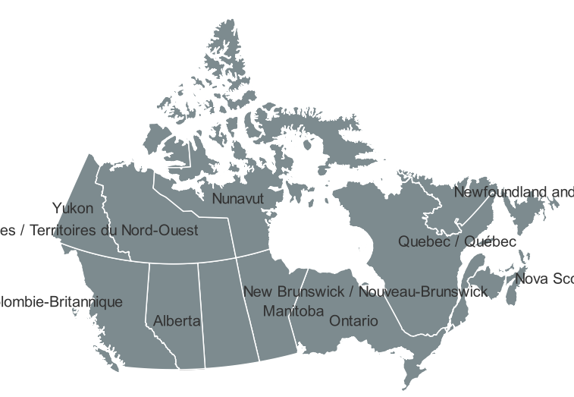

Location of Alberta in Canada.

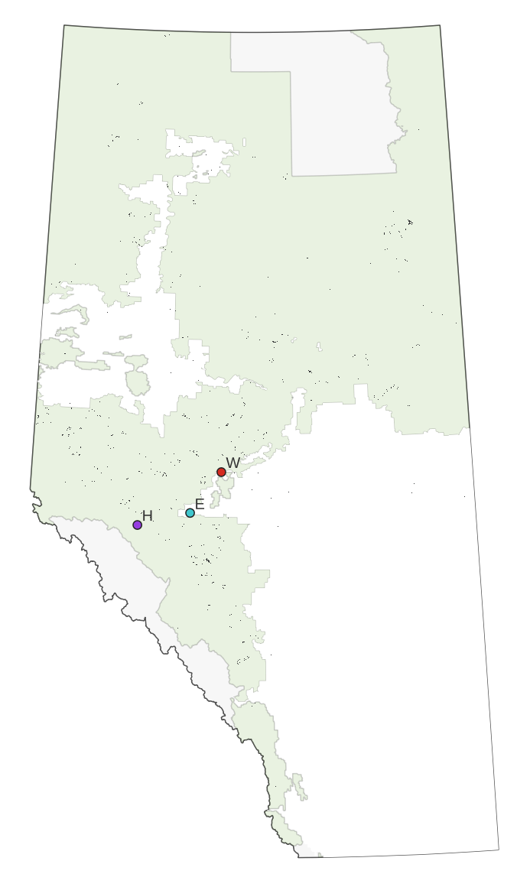

Harvest areas for 2009.

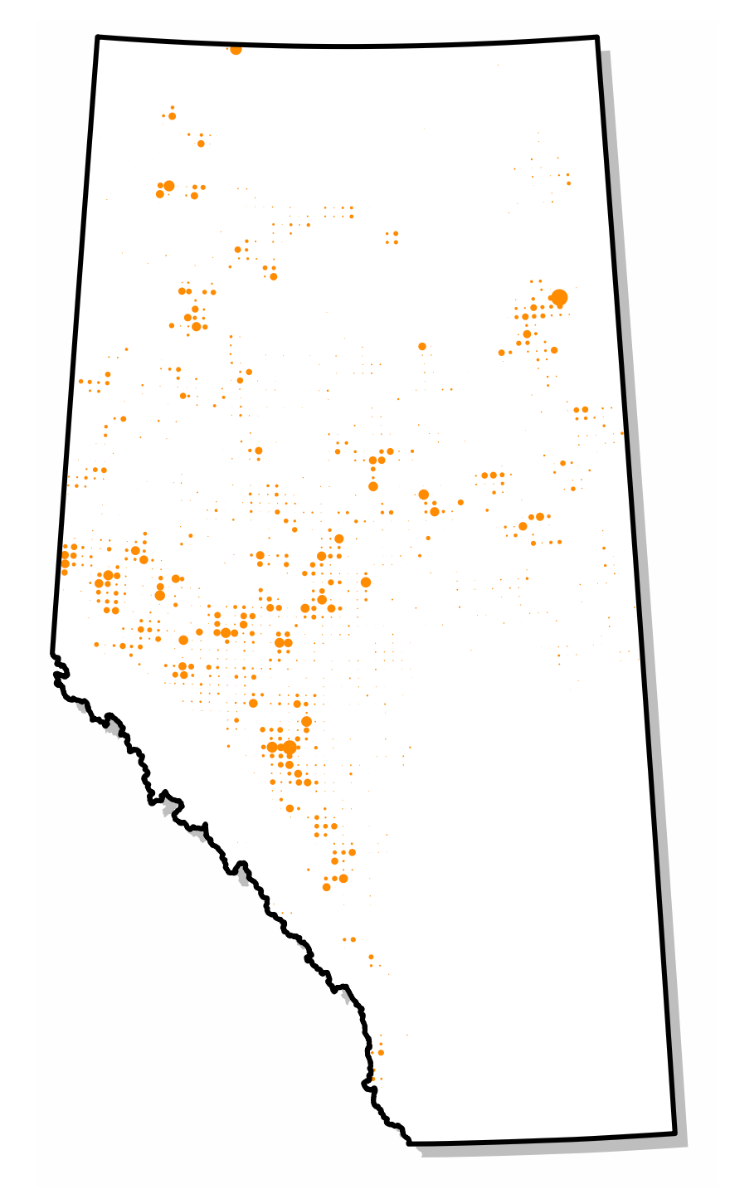

Harvest areas for 2009 with aggregated to township level. Only those townships where the proportion of total area harvested was 0.001 or greater are shown

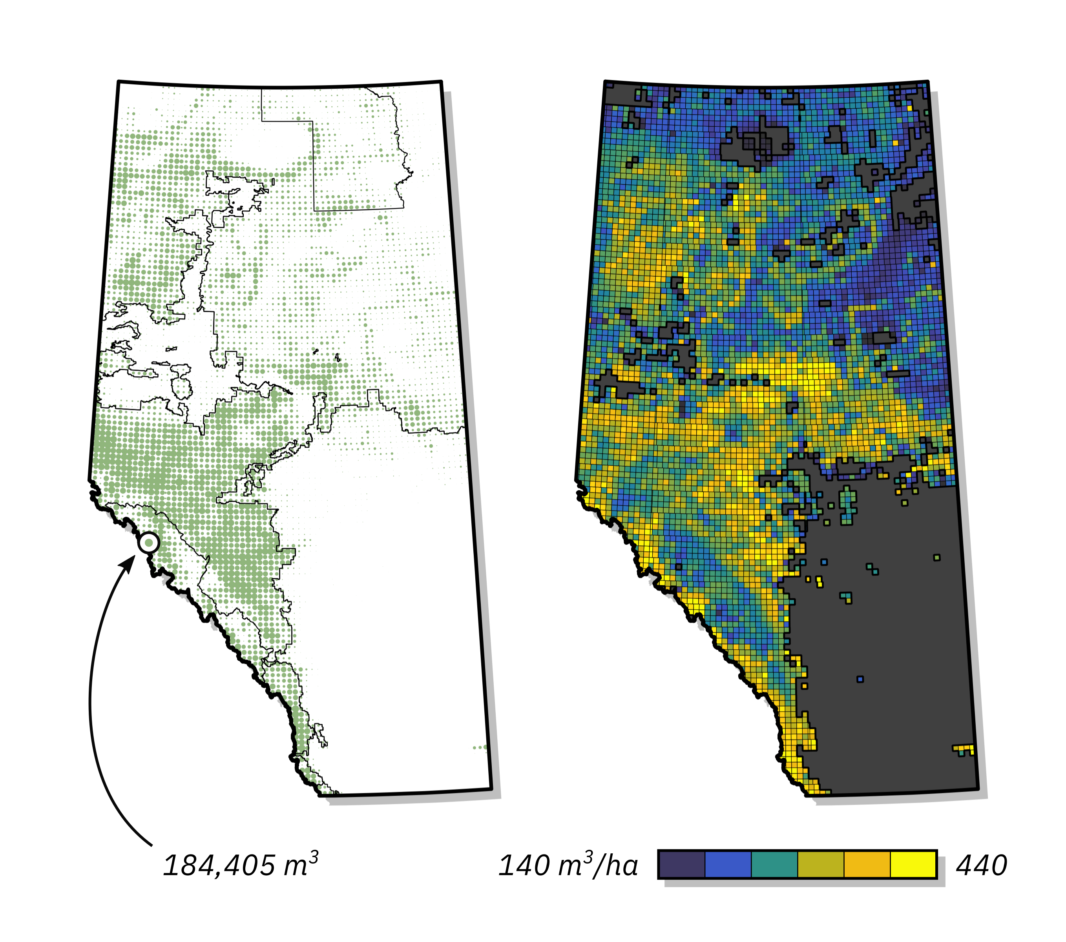

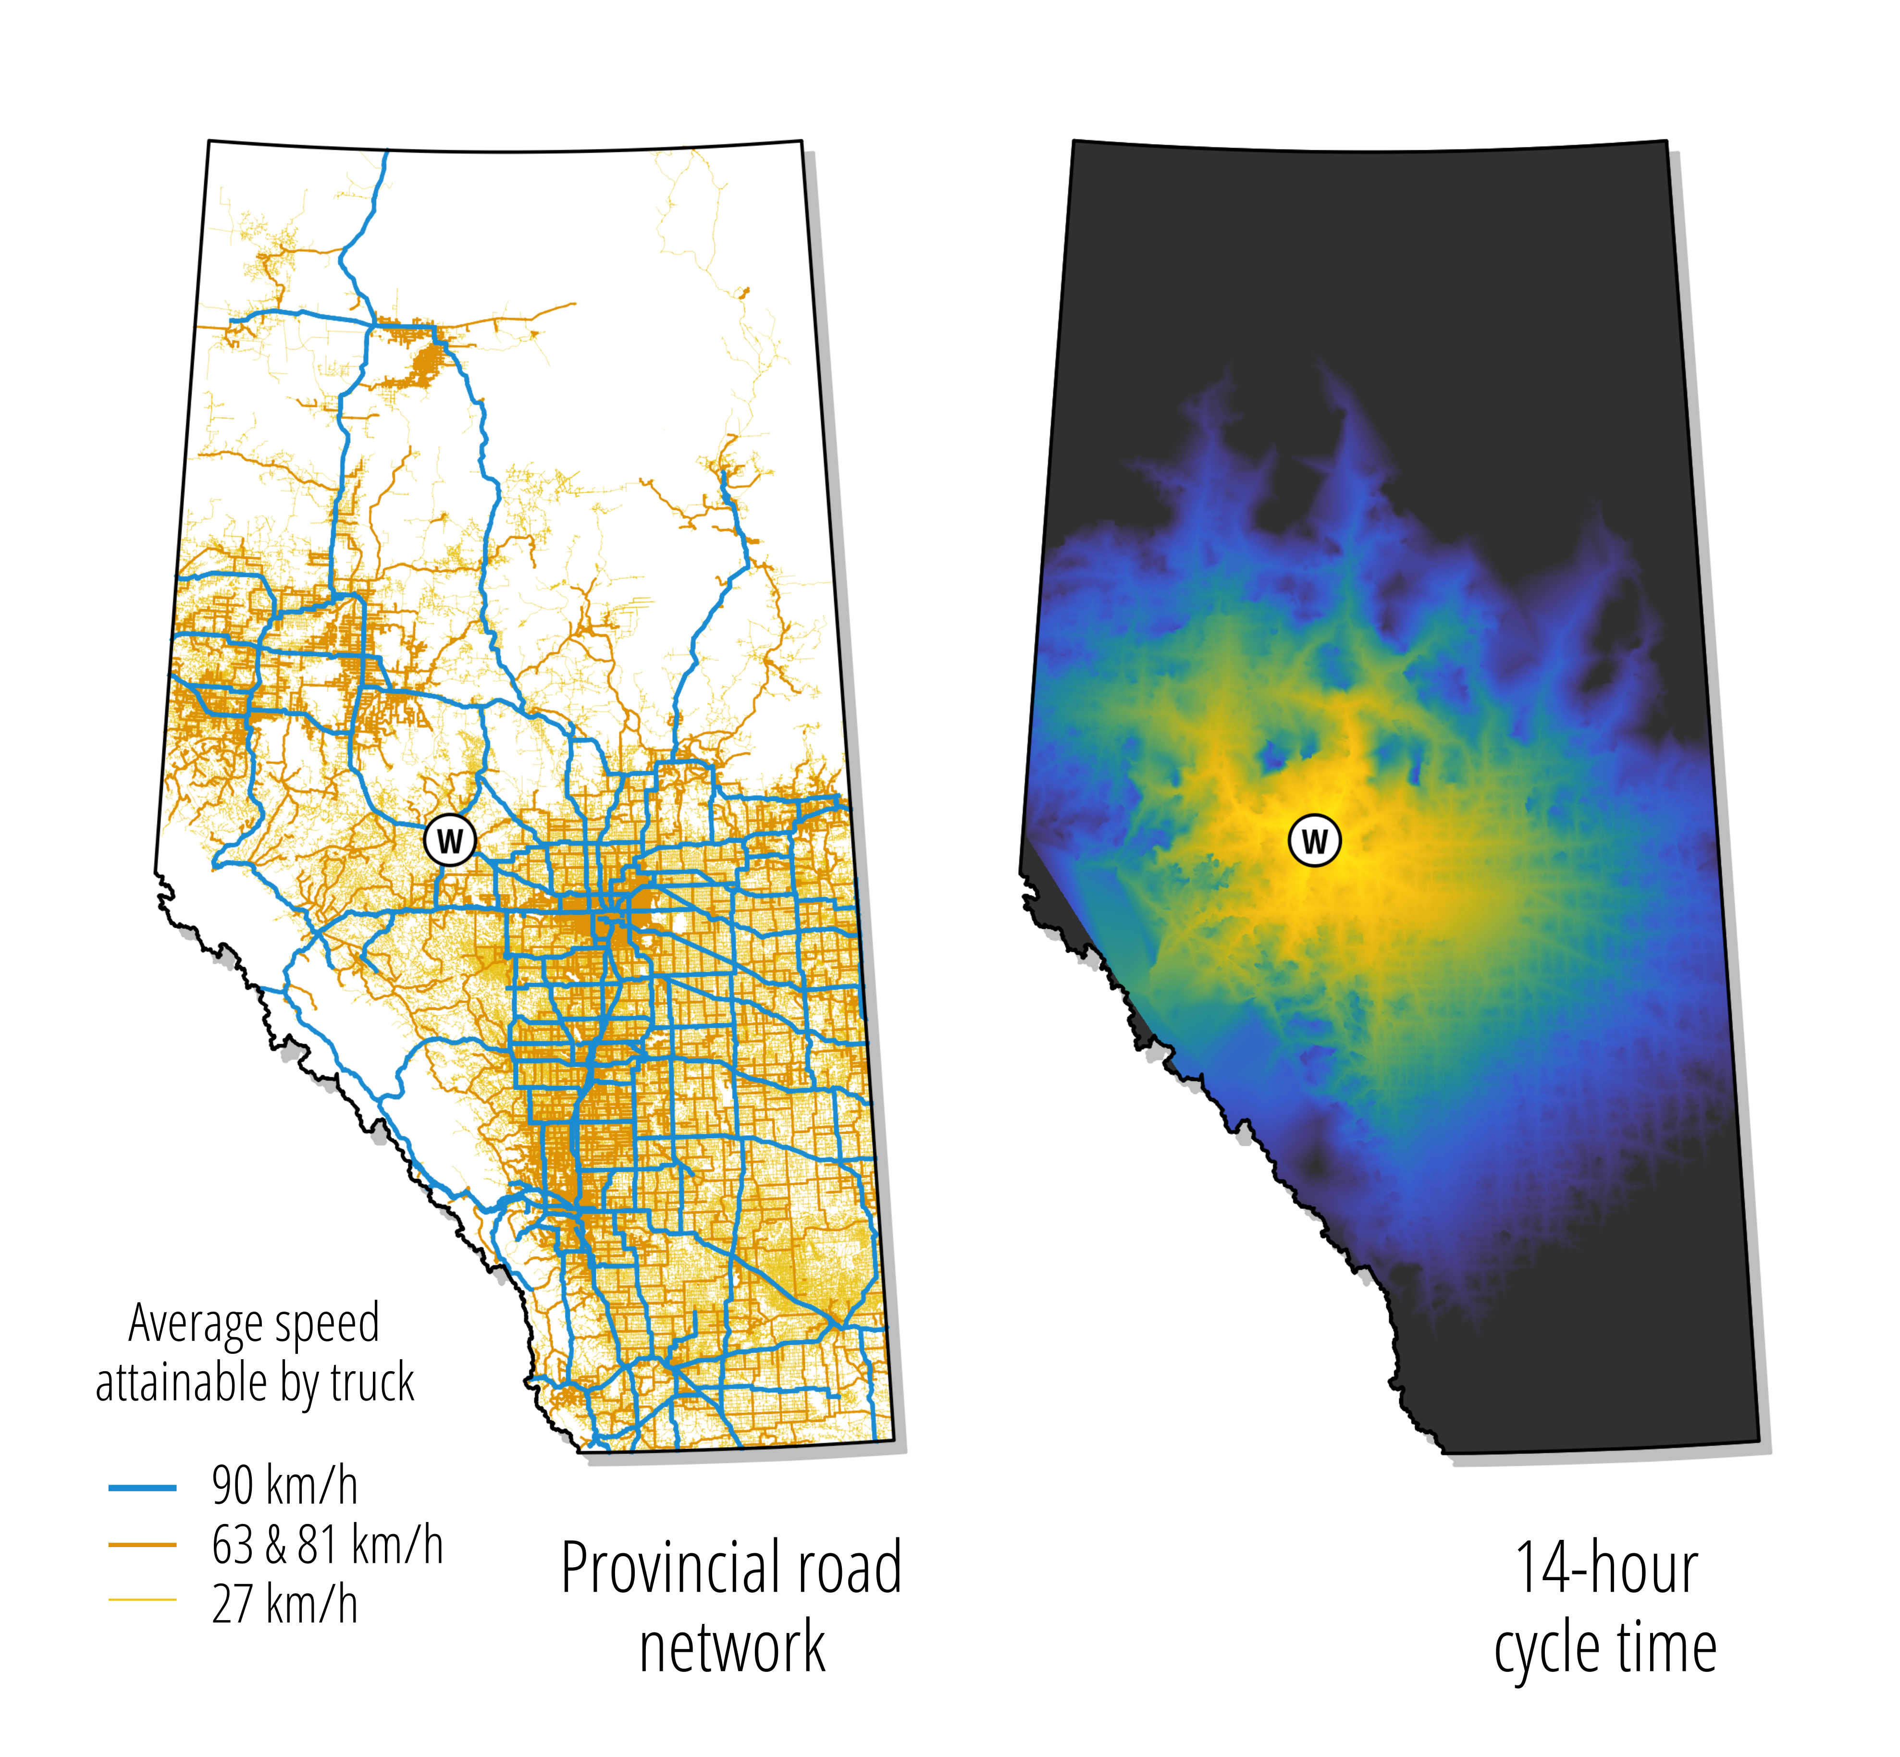

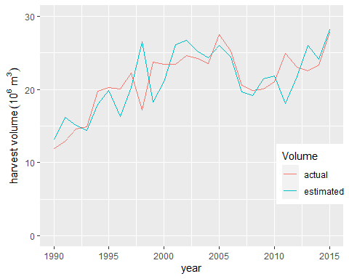

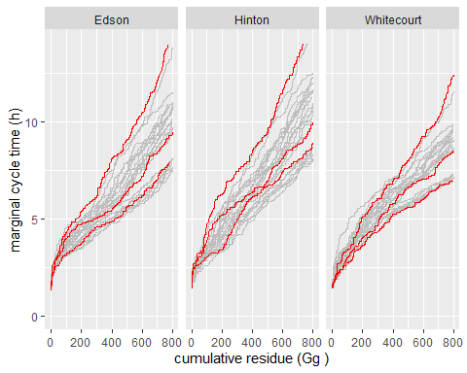

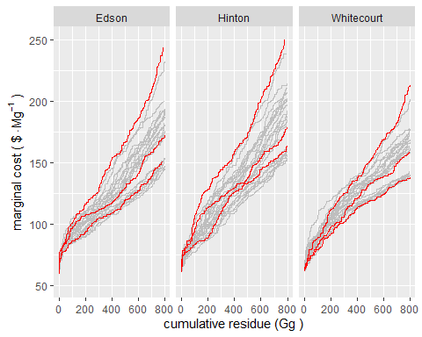

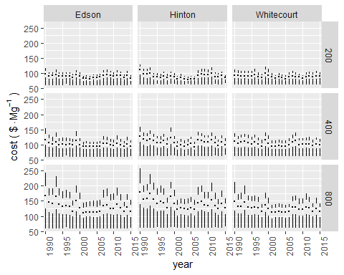

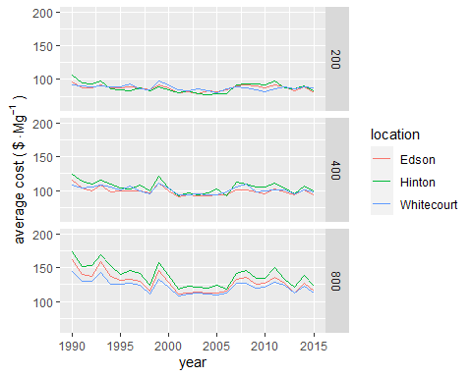

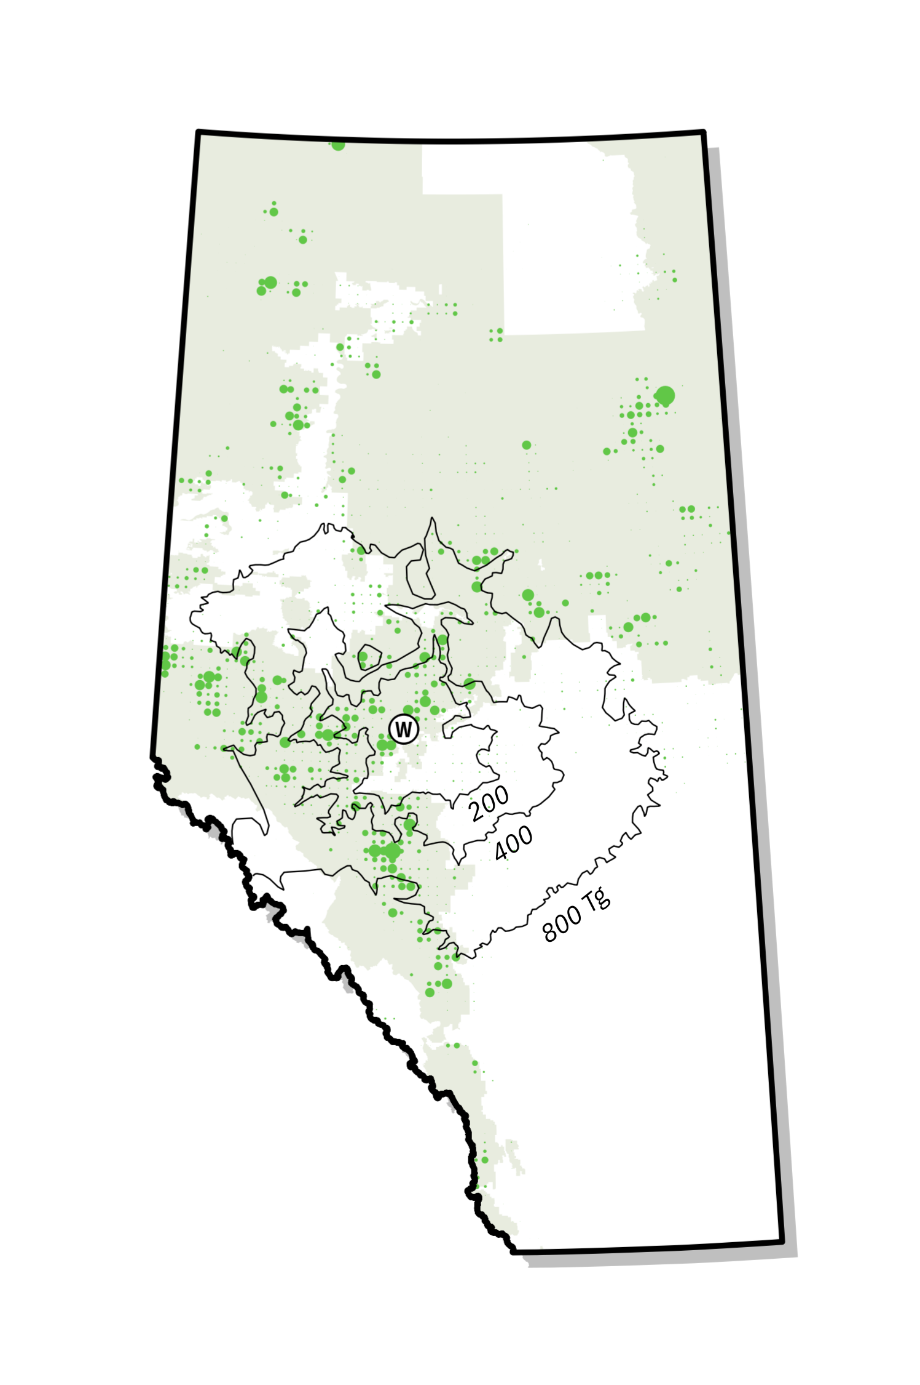

Relationship between timber harvest intensity and required supply area for facilities with biomass requirements of 200, 400, and 800 Gg/a. The area of the dots reflects the proportion of the area of each township harvest in 2009

